Spring Force Lab
By Derek Willingham
Purpose
- To analyze spring displacement and develop a
mathematical model describing the relationship
between spring force and the distance stretched.
- Calculate the force constant of the spring
- Apply the mathematical model to determine an
expression for the potential energy of the spring.

Materials
- Spring - an elastic object used to store mechanical energy. 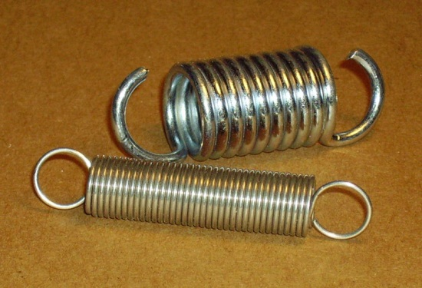

- Weighted Masses – increments of 20g, 10g, and 5g with a 50g base. 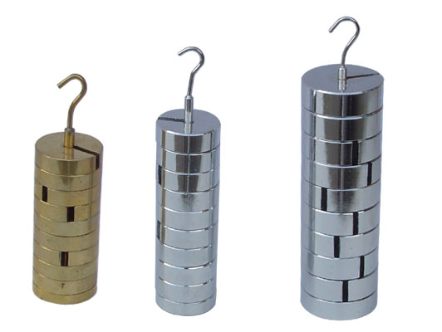

- Meter Stick

- Ring stand and mounting clamp
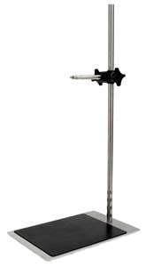

Procedure
- Set up lab equipment as follows.
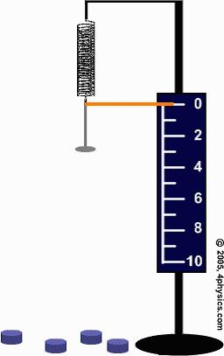
- Record the starting point of the bottom of the spring.
- Place a starting mass of 50g on the bottom of the spring and record the new displacement of the spring.
- Increase mass by increments of 20g for the next 9 trials and record the new displacement each time.
- Increase the mass by 10g for the next 4 trials and record displacement.
- Using F=mg calculate the F_{G} on the spring for all trials.

Data
Table- to derive force the mass was multiplied by gravity (9.81m/s²)
.05kg x 9.81m/s² = .4905N
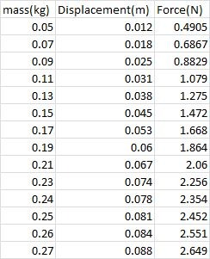

Data Analysis
Graph-
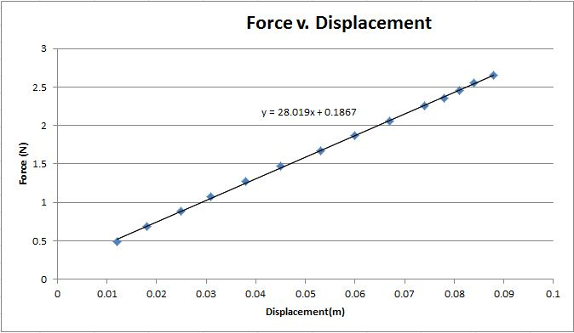
This graph presents a linear relationship between force and displacement of the spring. The slope is the force constant of the spring.

Calculations:
From the graph $k=∆F/∆x$:
Furthermore, $F(x)=-dU/dx$:
Using this equation we can solve for $dU$:
Then Integrate. $-U=\int{F\left(x\right)*dx}$:

Solve for $U$

$$U=\frac{1}{2}kx^{2}$$

$$k=28.019 N/m$$

$$\left[28.019x+.1867\right]=-dU/dx$$

$$-dU=F\left(x\right)*dx$$
$$-U=-\int{[28.019x+.1867]*dx}$$
$$U=(28.019/2)x^{2}$$

Conclusion

The expression for the potential energy of the spring was $U=\frac{1}{2}kx^{2}$. This was derived from the expression$F(x)=-dU/dx$. The potential energy of the spring that was used in this experiment can be modeled by the equation$U=(28.019/2)x^{2}$. “k” was found by observing the rate of change between the force on the spring and the spring’s displacement and is 28.019 N/m. As the force increased the spring’s displacement also increased in a linear relationship. This spring was an ideal spring and followed a linear pattern. While there may have been sources of error they did not skew the data in a unreasonable way and did not affect the overall outcome of the experiment. When deriving the equation for potential energy of the spring the y-intercept of the equation of the line of best fit was dropped because it was one, small and not extremely significant to our equation, and two, because the integration of the equation with the y-intercept included would create an equation that was not equivalent to the U of the spring.

