Simple Harmonic Motion Lab
Derek Willingham
Purpose:
- Develop the sinusoidal equations of motion for a pendulum.
- Compare the experimental period to the calculated period using $T=2π√(\frac{L}{G})$.
Equipment:
- Small Mass,
- Fishing line,
- Ring stand,
- Camcorder,
- Logger Pro,
- Excel.
Procedure:
- Set up pendulum and equipment to measure distance from center (refer to video for set up).
- Start recording at an adequate distance away to still see mass and meter stick clearly.
- Release mass from a height an appropriate distance away and record video for at least 4 complete cycles.
- Analyze video using Logger Pro and Excel and get time versus distance from center data.
- Calculate the period of the sin wave and compare it to the theoretical period derived from the above formula.
Data:
- Video Data – The video recording of the experiment can be found back on Derek’s AP Labs website on the page where this lab was found.
- Length of Pendulum: 38cm
- Tabular Data: (next page)
- Graphical Data:
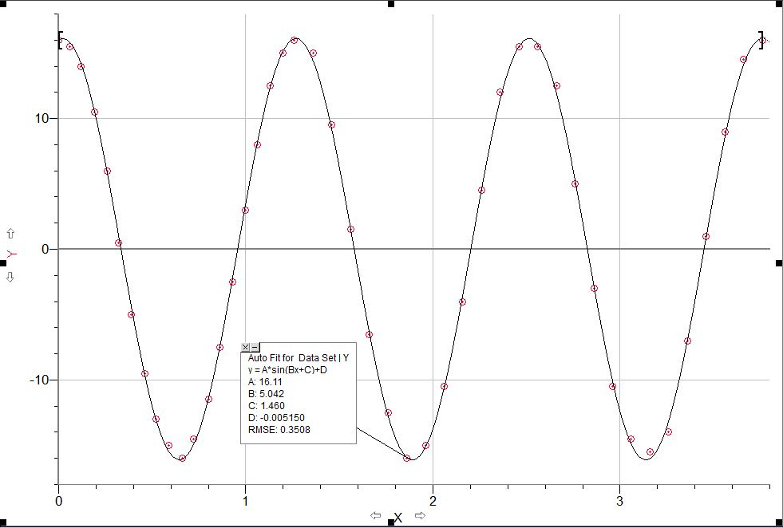
Data Analysis:
The experimental period derived from the sinusoidal equation found is 1.246s. This is found using the equation T = $\frac{2π}{B}$. The theoretical period of the same pendulum is 1.237s. This was found using the equation $T=2π√(\frac{L}{G})$ where L equals .38m. After calculating the percent error of the experimental data vs. the theoretical answer there is a .728% error.
% Error Calculation: [(1.246-1.237)/(1.237)] x 100 = .728%
Conclusion:
After the completion of this lab both of the objectives of this lab have been completed. The sinusoidal equation for the Simple harmonic motion of a pendulum has been formed and the experimental period was compared with the theoretical period. With a percent error of .728% this verifies the accepted relationship between the length of a pendulum and its period. Due to the insignificant amount of error no sources of error were present that could not be controlled. Possible improvements to the experiment would be using a HD camera that would provide better video quality and less motion blur.

