AP Physics C
Rotational Motion Lab

Purpose: To measure the translational acceleration of a falling object hanging from a pulley and validate that it exhibits rotational inertia consistent with a disk.

Equipment:
- Pulley
- Hanging Mass
- Video Camcorder
- Video Editing Software with frame by frame capability
- Large distance recording meter-stick
Procedure:
- Set up the pulley system so that the mass has an adequate distance to fall. Tie mass to one end of string and wind string around the pulley until hanging mass is at top.
- Release the mass and record its falling with the camcorder.
- Upload videos to video editing software and then record time vs. distance data in a table.
- Repeat steps 1-3 for desired number of trials.
- Take recorded data values and put them into Logger Pro and then generate a time vs. distance graph.
- Calculate acceleration of the falling mass with kinematic equations.
- Using sum of the torques and sum of the forces calculate the theoretical acceleration and compare to the experimental acceleration.

Data & Analysis:
Table and Graph
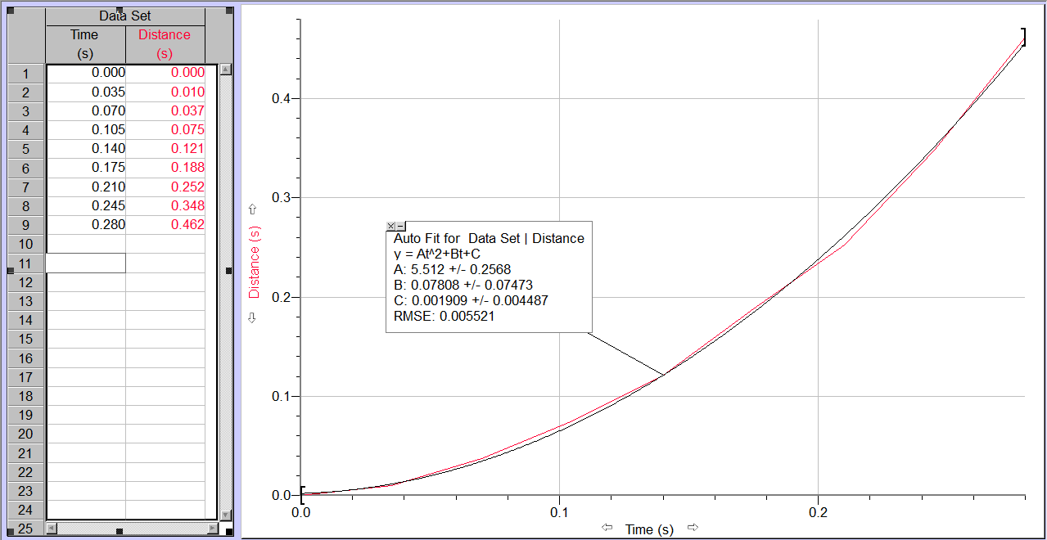
From this graph we derive that the acceleration of the falling object is .5a=A so therefore a=2A and the experimental acceleration from this trial is 11.024m/s².
We know that the radius of the pulley is

