Jupiter’s Moons: Exploration of Kepler’s Laws
Derek Willingham
Objectives:
- Determine the mass of Jupiter.
- Gain a deeper understanding of Kepler’s third law (the harmonic law).
- Learn how to gather and analyze astronomical data.
Background:
Ever since the dawn of man the heavens have been a sight to behold and a wonder to all. For hundreds of years astronomers and physicist have tried to understand what makes the universe move and react the way it does. In the mid-16th century major headway was made in the field of astronomical data of the heavenly bodies and their movement. This data was later observed, without permission, by a mathematician by the name of Johannes Kepler. From these extensive measurements he was able to deduce his three laws of planetary motion that governed the planets movement throughout the night sky. From these new empirical laws information that was before thought to be impossible to find could now be extrapolated. The mass of the planets could now be found out with unprecedented accuracy by using Kepler’s Harmonic Law in unison with Newton’s Law of Gravitation. After Kepler’s revelations Galileo used the creation of the telescope to view Jupiter more closely and discovered the presence of four of its orbiting moons. This became of paramount importance because the Jupiter System could be studied as a miniature replica of the entire solar system and give evidence to support the heliocentric theory.
Procedure:
The procedure for this lab can found online by clicking here or going to http://geddesphysics.weebly.com/analyzers-moons-of-jupiter.html.
Data:
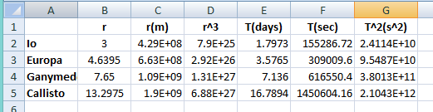
Data Analysis:
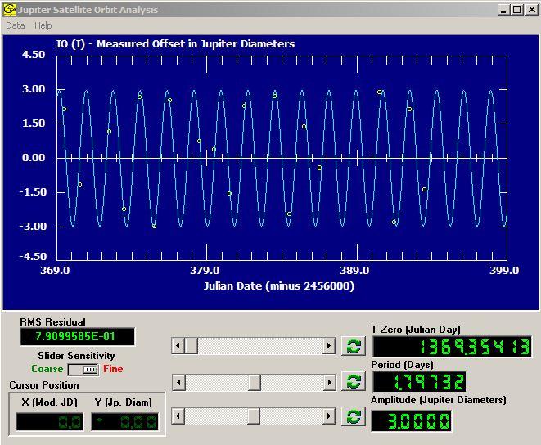
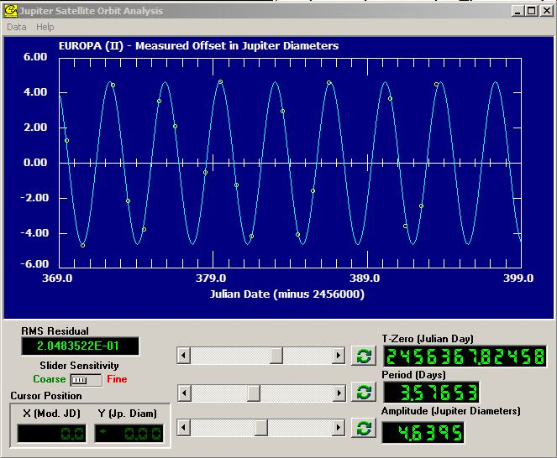
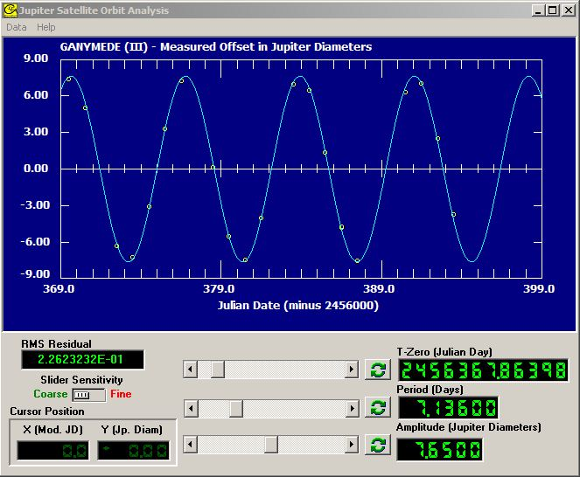
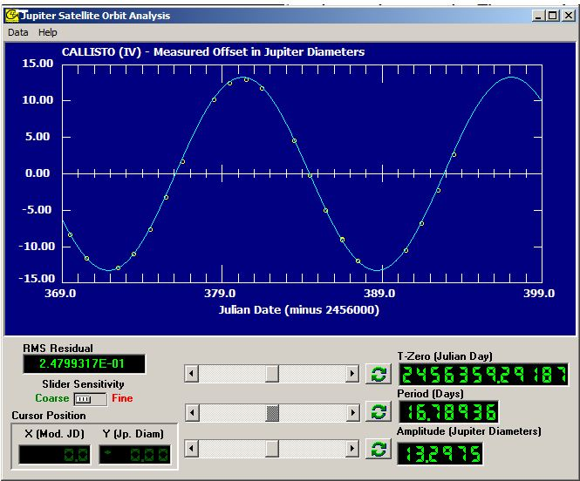
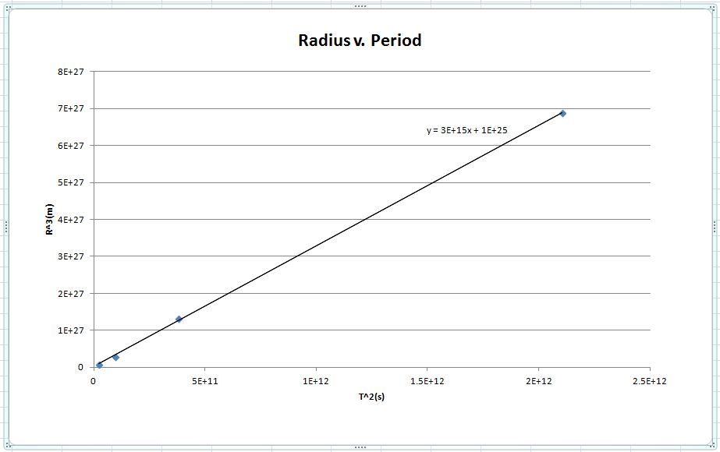
By graphing the radius cubed versus the period squared we can calculate the mass of Jupiter because it is know that $\frac{R^{3}}{T^{2}}=\frac{GM}{4π^{2}}$. After deriving the linear equation $R^{3}=\frac{GM}{4π^{2}}T^{2}$ it can be seen that $\frac{GM}{4π^{2}}$ is the slope of the line of best fit that we have conformed to our data. By setting the equation for the slope of the line equal to our experimental slope we are able to calculate M to be 1.7756x10²⁷kg. The accepted value of Jupiter’s mass is 1.8986x10²⁷kg. This leaves us with a percent error of -6.49%.
Conclusion:
- Calculate the percentage error with the accepted mass of Jupiter.
(1.7756x10²⁷+1.8986x10²⁷)/( 1.8986x10²⁷) X 100% = -6.49%
Jupiter has many moons, many of which are beyond Callisto. These planets will have a longer period due to the fact that they are farther away from Jupiter and because there is a positive linear relationship between the orbital distance from the center of Jupiter and the period of the orbit. If there was error introduced to the equation in the period or radius the radius error would have a larger affect on the results. This is because the radius is cubed, while the period is squared. By cubing the radius it would create an even larger error in the findings derived from the experimental data. When Galileo observed the moons of Jupiter orbiting Jupiter itself he realized that the Earth was not at the center of the universe after all. It helped him prove that things do not have to orbit the sun and can instead orbit other galactic bodies such as the sun.
After completing this experience I have derived the mass of Jupiter with very little percent error accomplishing objective 1. I have also come to better understand Kepler’s harmonic law and how it can be manipulated to provide key information about bodies and their orbiting satellites. Finally, by using the CLEA software I have been able to learn how to record astronomical data and successfully incorporate it to provide conclusive results about a planets characteristics. After completing all of the objectives of this lab and also successfully calculating Jupiter’s mass this lab has been extremely successful. Any error that could be a result from this experiment could be the improper calibration of the CLEA software and the inability to use a mouse for more precise measurements of the moons distances from Jupiter.

